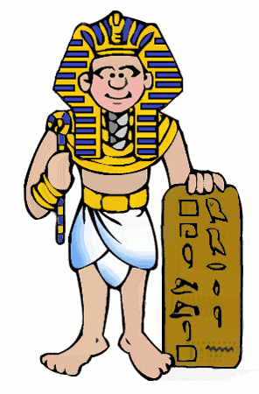
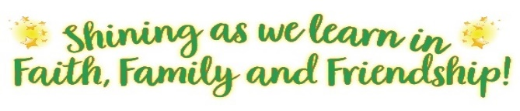
HISTORY

HISTORY CURRICULUM OVERVIEW
HISTORY STATEMENT OF INTENT
At St William of York we want our pupils to gain a coherent understanding of Britain’s past and that of the wider world and the influence the past has had on life in modern Britain. Our curriculum is carefully tailored to include a focus on local history to give pupils a deeper understanding of the society in which they live. We aim that our language rich curriculum will inspire pupil’s curiosity to know more about historical events. Pupils are encouraged to read, ask perceptive questions and think critically using sources of evidence to support their opinion. They should understand how people’s lives have changed and how diverse societies were (and still are!) and the challenges that were (and still are!) faced.
THE GOLDEN THREADS OF EYFS
    - Begin to make sense of their own life-story and family’s history
- Pupils name and describe people who are familiar to them
- Pupils talk about members of their immediate family
- Pupils comment on images of familiar situations in the past
- Pupils compare and contrast characters from stories, including figures from the past
YEAR 1
KEY CONCEPT YEAR 1 – Things were different in the past.
AUTUMN TERM | SPRING TERM | SUMMER TERM
What were homes like in the past? | How have toys changed in the past 100 years? | Who was the lady with the lamp?
YEAR 2
KEY CONCEPT YEAR 2- Sources of evidence –How do we know?
AUTUMN TERM | SPRING TERM | SUMMER TERM
Who were the first people in space? | What happened at the Great Fire of London? | Who was The Lion of Vienna?
YEAR 3
KEY CONCEPT YEAR 3- What does it mean to be ancient?
AUTUMN TERM | SPRING TERM | SUMMER TERM
What was life like from the Stone Age to the Iron Age? | Who were the Ancient Egyptians? | What did the Romans bring to Britain?
YEAR 4
KEY CONCEPT YEAR 4 – The evolution of the church
AUTUMN TERM | SPRING TERM | SUMMER TERM
Why did the Anglo Saxons choose to invade Britain? | Who were the Vikings? | How did life in Britain change during the reign of the Tudors?
YEAR 5
KEY CONCEPT YEAR 5 -What is social injustice?
AUTUMN TERM | SPRING TERM | SUMMER TERM
What was it like to live in Bolton during the Industrial Revolution? | Who were the Suffragettes? | What was life like for children and women on the home front during WW2?
YEAR 6
KEY CONCEPT YEAR 6 -What legacy did they leave?
AUTUMN TERM | SPRING TERM | SUMMER TERM
What is the legacy of the Ancient Greeks? |  | When did the Early Islamic civilisation begin and how enormous did it become?

