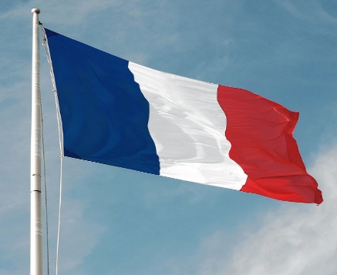
ST WILLIAM OF YORK CATHOLIC PRIMARY SCHOOL
MFL
Knowledge & Vocabulary Map

YEAR GROUP: 4 | SPRING TERM
TOPIC | Ou peut-on parler francais?

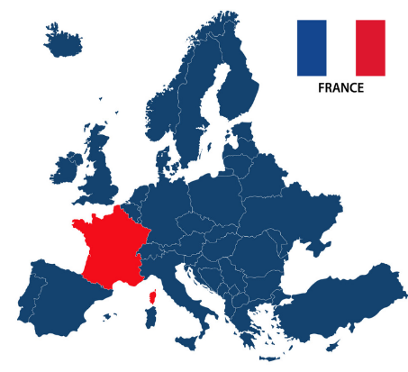
KEY STICKY KNOWLEDGE -RECAP AND REVISIT YEAR 3
- Know that there are 29 different French speaking countries. | - Know that south of France has a warmer climate than the north.
- Know that the currency in France is Euros.

FRENCH VOCABULARY

Nord | La Suisse | Le bus | Il pleut
Sud | Le maroc | La moto | Il fait du soleil
Ouest | La Tunisie | Le vélo | Il fait du vent
est | Le Luxembourg | L’avion | Il neige
Francophone | Le Canada | A pied | Il fait chaud
La Belgique | La voiture | Le taxi | Il fait froid

